**Pivot Project Sales Analysis**

Open Pivot Project Sales Analysis and save it as Pivot Project Sales Analysis (with your name at the end)

1. Create the following pivot table on a new worksheet:



* 1. Modify the pivot table to also display the Total Sale as a SUM.



* 1. Modify the report layout to Tabular form and rearrange the fields as necessary to create the following pivot table.



* 1. Name the sheet tab Q1

1. Go back to the Data sheet and create a pivot table on a new worksheet to answer the following question, what are the Total Sales by Time and County on Sundays and Mondays in Jun and Jul? Use the following guidelines:
   1. Change the heading "Row Labels" to "Time"
   2. Change the heading "Column labels" to "Region"
   3. Arrange the time in order AM, Midday, PM (Hint: Drag and Drop to rearrange)
   4. Sort the regions from left to right in ascending order based on the Grand Total (Hint: Click the arrow next to the County label. Choose More Sort Options… Click Ascending and then click the Drop-down arrow under Ascending and choose Sum of Total Sale. Click More Options… Choose Grand Total)
   5. Add a slicer to select the Day
   6. Add a Timeline to select the Date
   7. Format the numbers in Currency format with zero decimal places
   8. Name the sheet tab Q2

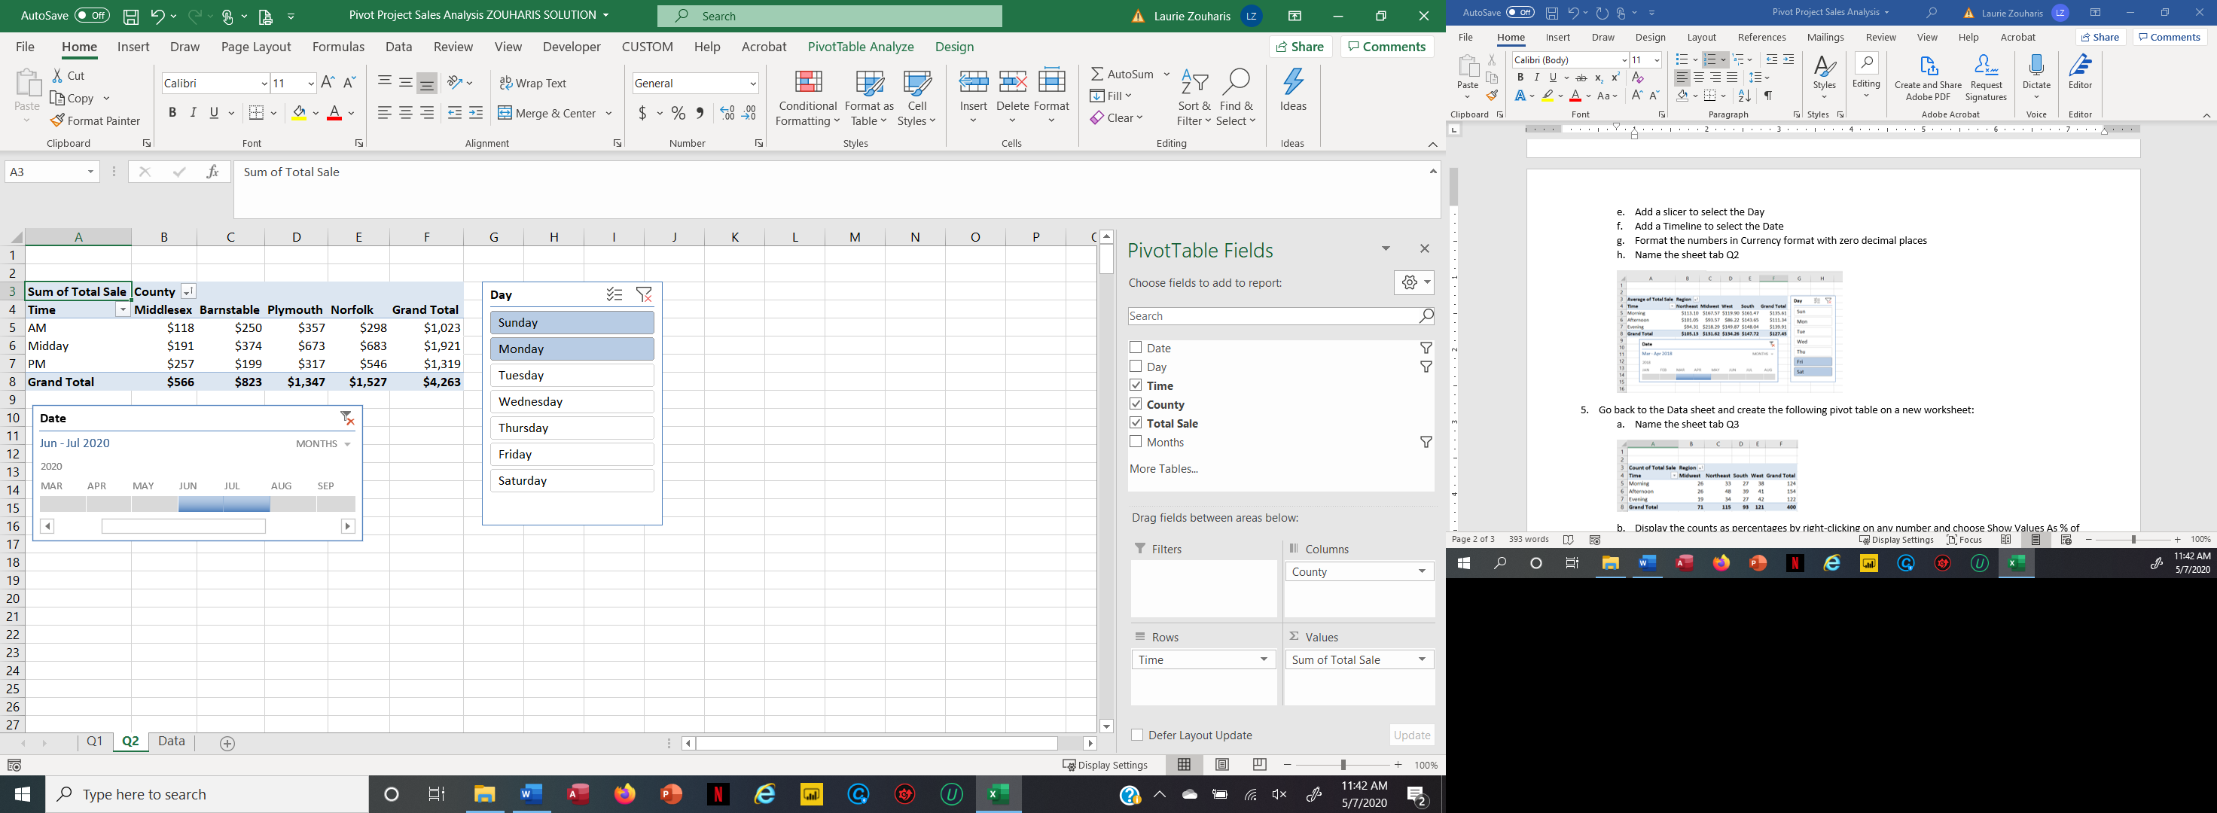

1. Go back to the Data sheet and create the following pivot table on a new worksheet:
   1. Name the sheet tab Q3



* 1. Display the counts as percentages by right-clicking on any number and choose Show Values As % of Column Total



* 1. Create the following pivot chart from the Pivot Table. Notice the Maximum Bound and Major Units on the chart axis.

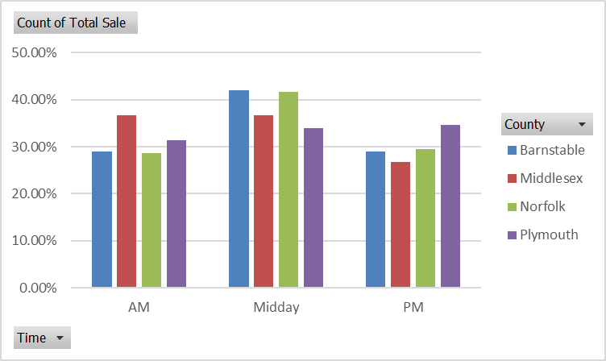

1. Go back to the Data sheet and create a pivot table on a new worksheet to answer the following question, what time of day has the lowest Total Sale and at that time of day in which County is the lowest total sale?
   1. Name the sheet tab Q4
   2. Format as shown below



1. Go back to the Data sheet and create a pivot table on a new worksheet to answer the following question, what County has the highest Total Sale and in that County what day had highest Total Sale?
   1. Name the sheet tab Q5

